**Experiment 6**

**Name: Shubham Mourya SAP ID: 60017230110**

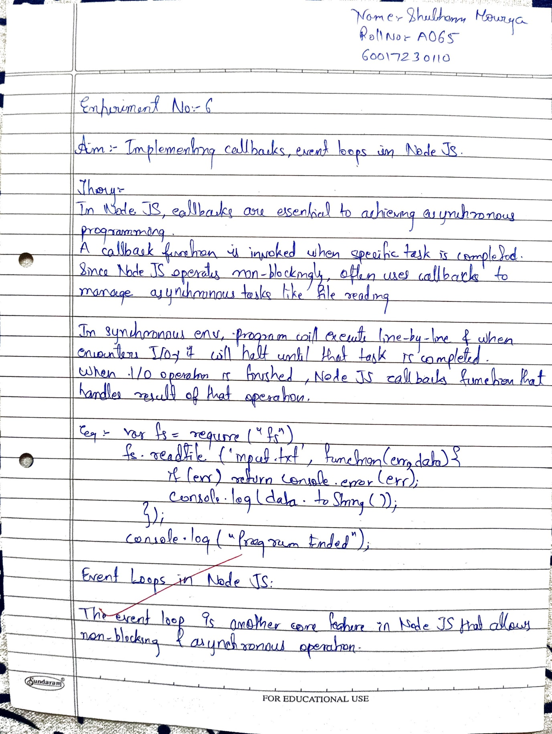

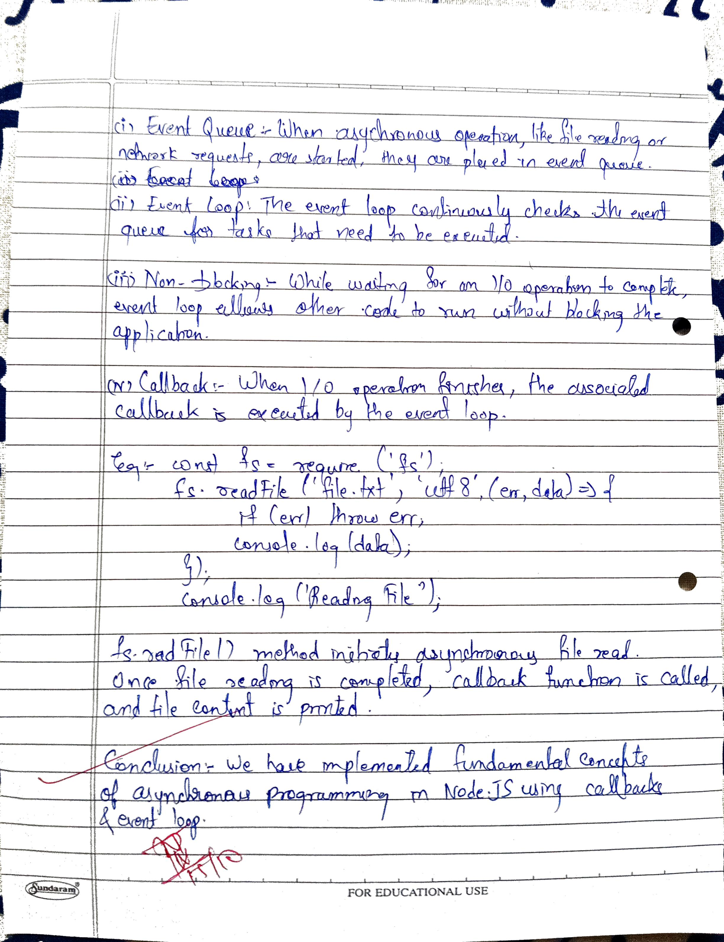

|  |  |
| --- | --- |
| **Date:** |  |
| Aim | **Implementing Callbacks, Event loops in Node.js** |
| Software |  |
| Pre-requisite | Active internet connection |
| Theory | What is Callback?  Callback is an asynchronous equivalent for a function. A callback function is called at the completion of a given task. Node makes heavy use of callbacks. All the APIs of Node are written in such a way that they support callbacks.For example, a function to read a file may start reading file and return the control to the execution environment immediately so that the next instruction can be executed. Once file I/O is complete, it will call the callback function while passing the callback function, the content of the file as a parameter. So, there is no blocking or wait for File I/O. This makes Node.js highly scalable, as it can process a high number of requests without waiting for any function to return results  Example of Non-Blocking Code:  1. Create a text file named input.txt with the following content.  Tutorials Point is giving self-learning content to teach the world in simple and easy way!!!!!  2. Update main.js to have the following code − var fs = require("fs"); fs.readFile('input.txt', function  (err, data) { if (err) return console. Error(err); console.log(data.toString());  });  console.log("Program Ended");  3. Now run the main.js to see the result −  $ node main.js  4. Verify the Output.  Program Ended  Tutorials Point is giving self-learning content to teach the world in simple and easy way!!!!  The program does not wait for file reading and proceeds to print "Program Ended" and at the same time,  the program without blocking continues reading the file.  Event Loops  The Event Loop and Emitters are fundamental concepts in Node.js, which make it an efficient and event driven environment for server-side programming. Let's explore these concepts in detail:  Event Loop:  The event loop is a critical component of Node.js that enables non-blocking, asynchronous I/O operations.  It's responsible for managing the execution of code in response to events, allowing Node.js to efficiently handle multiple concurrent connections without blocking the main thread.  Here is how the event loop works:  Event Queue: When asynchronous operations (such as reading files, making network requests, or  handling user input) are initiated, they are placed in an event queue.  •Event Loop: The event loop continually checks the event queue to see if there are any events (such  as callbacks or promises) that need to be executed.  Non-Blocking: While waiting for I/O operations to complete, the event loop allows other code to  run, ensuring that the application remains responsive and doesn't block.  •Callbacks: Callback functions are often used in Node.js to handle events when operations are  completed. When an event is ready to be processed, its associated callback function is executed.  Example of an event loop in Node.js:  const fs = require('fs');  // Asynchronous file read operation fs.readFile('file.txt', 'utf8', (err, data) => { if (err) throw err;  console.log(data);  });  console.log('Reading file...');  In this example, the file read operation is asynchronous, and the callback function is executed once the  operation is complete. While waiting for the I/O operation to finish, other code (e.g., the console.log) can run without blocking. |
| Code | // Import the file system module  var fs = require("fs");  // Example of multiple async operations  // Asynchronous file read operation  fs.readFile('input.txt', function (err, data) {      if (err) {          return console.error(err);  // Handle any errors      }      // Print the file content      console.log("File Read: " + data.toString());  });  // Timeout operation to simulate event loop behavior  setTimeout(() => {      console.log("Timeout 1: This will be executed last.");  }, 3000);  setTimeout(() => {      console.log("Timeout 2: This will be executed second.");  }, 1000);  // This message will be printed before the file content due to asynchronous nature of operations  console.log("Program Ended: This will be executed first."); |
| Result |  |
| Conclusion | In this experiment, we explored the concepts of callbacks and event loops in Node.js, highlighting their significance in enabling non-blocking I/O operations. By utilizing callbacks, Node.js can efficiently handle multiple tasks concurrently without waiting for each operation to complete, which enhances its scalability and performance. The example demonstrated how asynchronous file reading works, allowing other code to execute while waiting for the file I/O to finish. Understanding these concepts is crucial for developing efficient server-side applications that remain responsive under heavy loads. Overall, callbacks and event loops are foundational to the event-driven architecture of Node.js, making it a powerful tool for modern web development. |